TÍMEA ERDEI
Garden and Landscape Architect
BSc, 7. semester
Corvinus University of Budapest
Faculty of Landscape Architecture
Supervisor:
Zsombor Boromisza
assistant professor, BCE TÁJK

The role of green space elements in traffic noise reduction

There are several solutions for the abatement of the increasingly significant noise pollution, but we have little information about the accurate noise reduction effects of the narrow vegetation belts in settlements. The goal of my research is the quantification of the noise reduction effect of these green space elements in urban environment, that conduce to the effectiveness of planning. My goal is additionally to raise awareness on the role of the narrow vegetation belts in noise abatement, and to determine the influential factors of noise reduction.
I began my research with the review of the Hungarian and the international literature. This was followed by the measurements of noise, and working-out the assessment method of the vegetation. The 7 measurement points are situated in Veszprém, my purpose was to assess various vegetation forms. The noise measurements were made in the frost and in the frost-free season as well, by Judit Takács, a student of the Pannon University in Veszprém. I began the exhibition of the study area with the overview of the planning antecedents, this was followed by the investigation of the study area. The investigation was carried out in three spatial scales: part of settlement, street and measurement point. After the delineation of study areas I made the surveys. At the measurement points I surveyed the woody vegetation, concluding the attributes of the tree and shrub individuals in a separate table. I worked out 13 indicators for trees, and 12 indicators for shrubs, e. g. habitus, size of leafs. In addition I examined the aesthetic, ecological and functional significance of the stands, e.g. the most important characteristics of the front gardens, because these can contribute to the abatement of noise too. I documented the survey on an analysis layout with the scale of 1:2000 and 1:500, and on cross sections of the measuring vegetation belts.
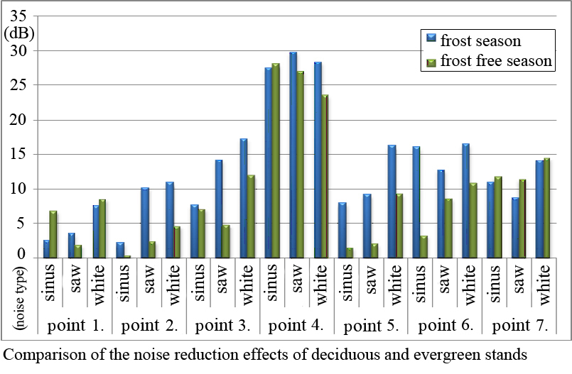
The relationship of the noise measurement’s results and the green space assessment’s results was analysed in the next step. My intention was to evaluate it from different perspectives, e. g. influential effects of seasons and spatial extent; comparison of the deciduous vegetation belts with deciduous stand; and the investigation of other functions of these vegetation belts. Based on the results and the investigation of the settlement’s part, I determined those parts of the study area, where it’s necessary to plant more vegetation, the forms of vegetation stands and further research goals.

