ALEXANDRA NÉMETH
Geology MSc.
MSc, 1. semester
Eötvös Loránd University
Faculty of Science
Supervisors:
Orsolya Sztanó
associate professor, ELTE TTK
István Szente
museologist, ELTE TTK

Evidence of tidal cyclicity in the Budafok Sand Formation based on ostrea growth lines

Evidence of tidal cyclicity in the Budafok Sand Formation based on ostrea growth lines
The Budafok Sand Formation accumulated during the Eggenburgian on the western coast of the North Hungarian Palaeogene Basin, which became a southward tapering bay by the Early Miocene. Although it was hypothesized earlier that deposition occurred in a tide induced environment just like the Pétervására Sandstone on the eastern side of of the bay, it is difficult to recognize tidal parameters in the deposit. My aim was to check if tidal patterns are recognizable in the growth lines of certain molluscs from the sand and to understand the effect of the tide in this environment.
Eight shells of Crassostrea gryphoides (Schloth) were collected from the outcrop of Budafok Sand in the end of Pék Street, Budafok. Shells were cut and their ligament areas were polished parallel to their ventral plains. Coated with coal, these pieces were put under electron microscope, where their growth lines were observed in 200-300x magnification.
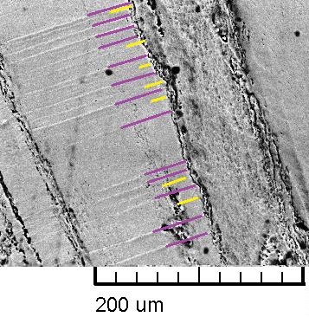
Cyclic variation of growth line strength and in thickness of growth increments were recognized in the shells. Groups of six-eight lines are appearing five times on the polished plain, always with the same distance. Pairs of strong and dim growth lines are also visible, the latter tends to dissappear completely. On a larger scale, cyclic variation in growth rates was recognized.
A semi-diurnal tide with diurnal inequality reflected by the variation of growth lines and growth increments on the backscattered electron images. From the extreme changes in the pattern of the diurnal inequality it is suggested that examined specimens lived in the lower intertidal zone. Even the seasonal variability of their living conditions is revealed: in winter lack of food and cold, in summer anoxia could put back the growth rates of the shells.
Accordingly the Budafok Bay had semi-diurnal tide with diurnal inequality to take effect on siliciclastic deposition and on the biota living there. This study confirmed the conjecture by Báldi, 1957 based on the appearance of „tidal flat facies”.

