IBOLYA ZITA PAPP
chemist
MSc, 10. semester
University of Szeged
Faculty of Science and Informatics
Supervisors:
Ákos Kukovecz, Dr
associate professor, SZTE TTIK
Gábor Kozma
junior research fellow, SZTE TTIK

Investigation of multiwalled carbon nanotubes modified cellulose-nitrate membrane filters

Membrane filters including cellulose nitrate have been used for solid-phase extraction of trace species such as organic species, some anions and heavy metal ions in various media. The most attractive features of membrane filtration technique are the simplicity and rapidity [1]. Since their discovery in 1991, carbon nanotubes have generated huge activity in most areas of science and engineering due to their unprecedented physical and chemical properties [2].
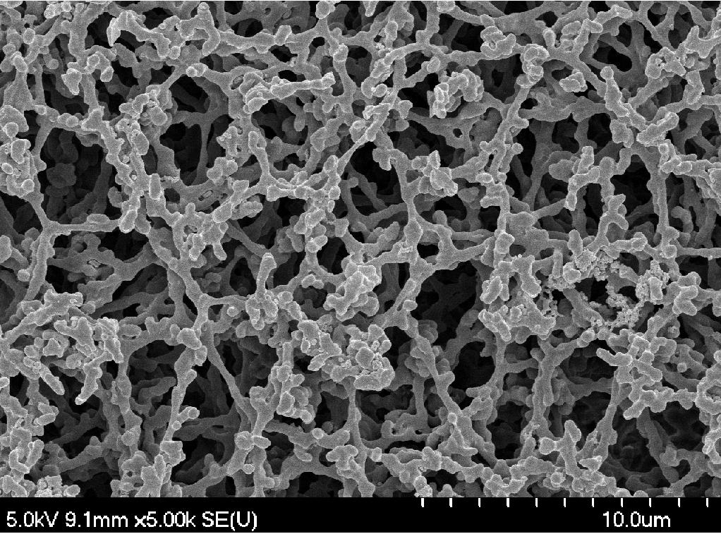
Figure 1. SEM picture of 1,0 um pore size cellulose nitrate membrane
First of all, the different pore size cellulose nitrate membrane filters were examined with scanning electronmicroscopy, average pore sizes and fiber diameters were investigated by Image-Java application. After that, multiwalled carbon nanotubes with different sizes, milled by planetary ball mill, were filtrated into the pores of membrane filters. The results were examined by SEM and atomic force microscopy were also used. Mechanical properties of these films was also investigated, measured by dynamic mechanical analysis.
[1]: Mustafa Soylak, Rukiye Sungur Cay, Journal of Hazardous Materials, Volume 146, Issues 1–2, 19 July 2007, Pages 142-147
[2]: Róbert Rémiás, András Sápi, Róbert Puskás, Ákos Kukovecz, Zoltán Kónya, Imre Kiricsi, Chemical Physics Letters, Volume 482, Issues 4–6, 12 November 2009, Pages 296-301.

