KLÁRA CSERNE
Theatre Dramaturgy
Unified, 5. semester
University of Theatre and Film Arts
Supervisor:
Magdolna Jákfalvi
professor, SZFE

Misunderstood Animals

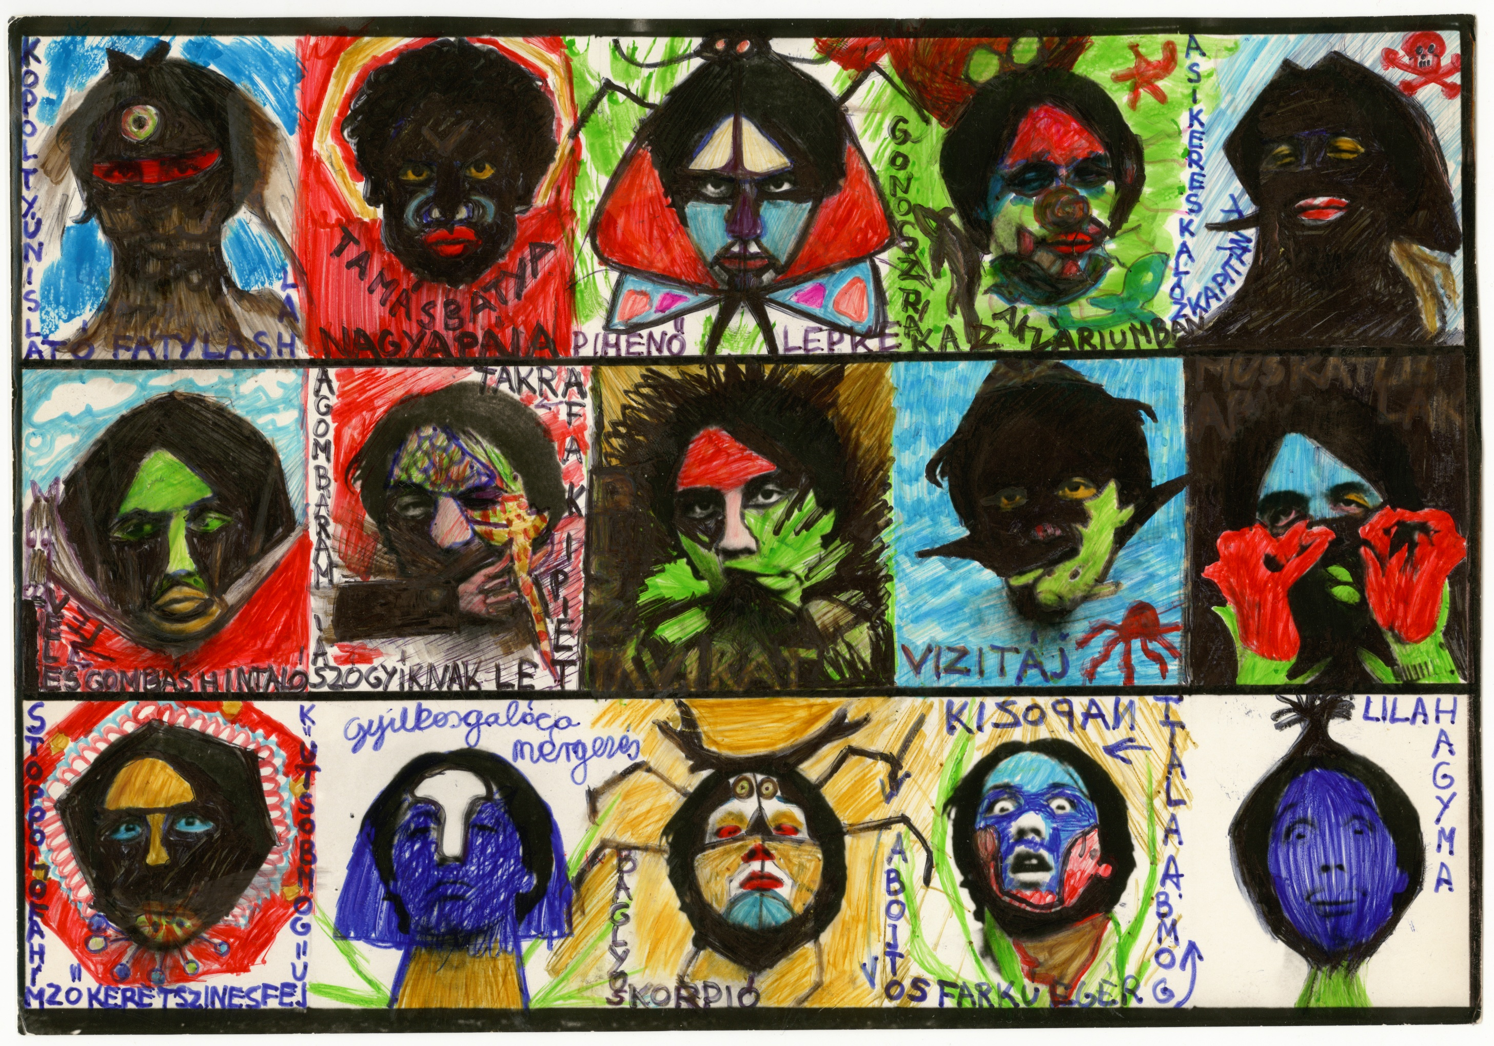
László Cserne, my paternal uncle committed suicide in 1983 - years before I was born. His major work - according to his contemporaries and friends - was he himself, his life events and his own body. He made paintings, tattoos, sculptures and wrote books. I attempt to understand László Cserne as an artist through his handwritten book titled Misunderstood Animals. My point of view cannot be objective at all, but my involvement (although we never met in person) as a family member has a general validity - as the Kádár-era is a personal experience for everybody living now in Hungary (no matter if born before or after the transition). If we don’t consider the Kádár-era the direct past of the recent times, whose traces live on in every member of the society, we might feel a kind of nostalgy for it - but it becomes clear soon that it is not worth longing for.

