GABOR NEMETH
Industrial Design Engineer
MSc, 1. semester
University of West Hungary
Faculty of Wood Sciences
Supervisor:
Dr. habil.Kovács Zsolt PhD
professor, NYME FMK

"Freedom" kneeling chair design

The topic of my thesis is designing a special multifunctional kneeling chair using conventional product designing and engineering techniques.
At the beginning of the thesis I reviewed the evolution of kneeling chairs and presented the most popular chair models available on the market (sorted into 2 major categories by their price). After that I reviewed the ergonomical background of these chairs, drawing vital conclusions for the actual designing process such as the ideal sitting posture for an adult human.
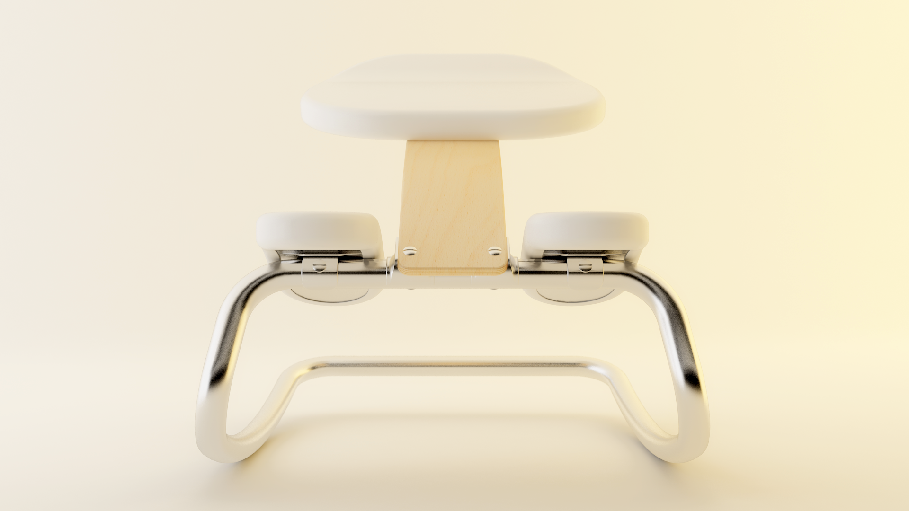
During the design process my main goal was creating an independent piece of furniture which people can use anywhere around them – for example as a relaxation chair for home or as a working chair for office environment. In order to fully accomplish this objective I needed to develop a sleek, traditional design combined with organic materials. For this I reviewed the former work of Alvar Aalto, Le Corbusier and Peter Opsvik, whose unique functionalist style is very close to what I’ve had in mind for this project. The material templates used by these great designers also suited the previously established idea (using steel, wood and leather as base materials), so their work inspired me even more.

