ESZTER BREBOVSZKY
Border Policing
BA, 3. semester
National University of Public Service
Faculty of Law Enforcement
Supervisor:
Dr. habil Ilona Bodonyi
college associate professor, NKE RTK

Media effect – Turning into a criminal

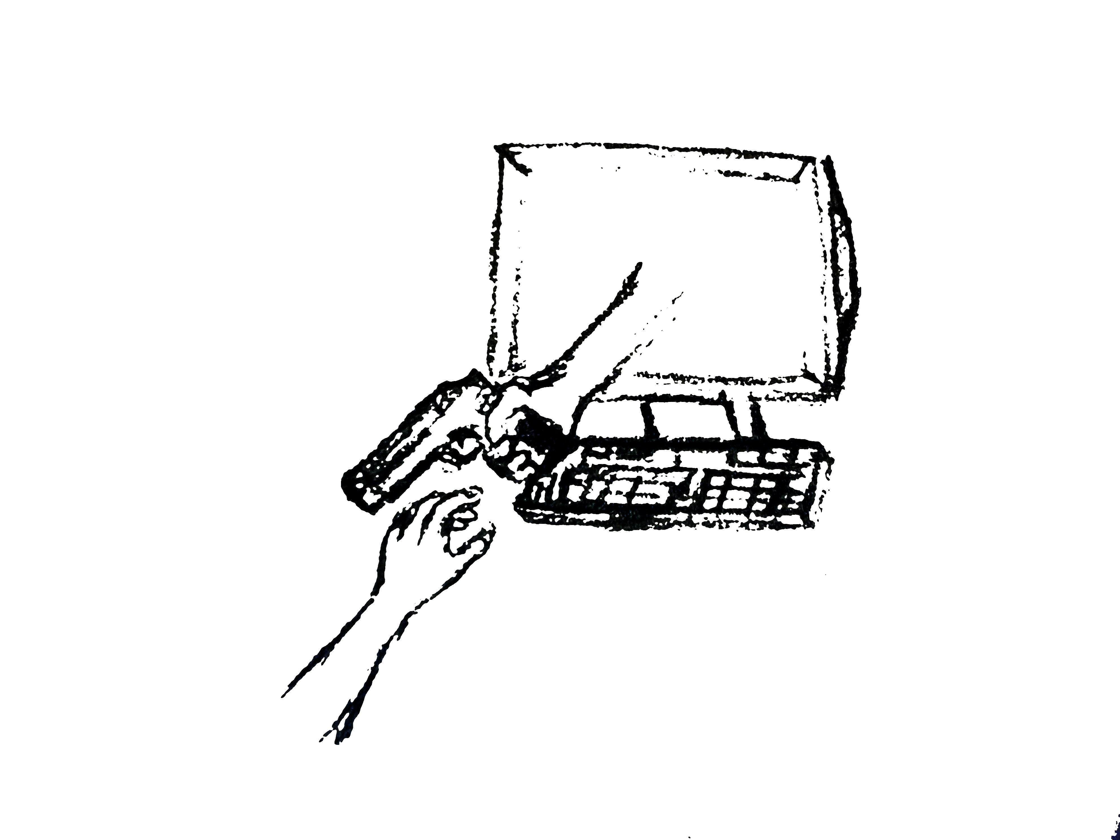
The study paper with the title ‘Media effect – turning into a criminal’ deals with the phenomena of new criminal acts and motivation created by the technical development of the 21th century.
The capital question of the study is: whether aggression and violence mediated by mediums of the modern age (like movie, computer games) could have such an effect on the individual that it leads him or her to commit a crime.
After clarifying the basic concepts like media and crime the study gives an overview about contemporary researches on the relation of delinquency and media, its results and mostly about its conclusions giving guidelines for further researches.
The study paper also presents actual cases in order to show, that an actual movie or game could lead somebody to commit a crime, or it defined the manner as the crime was carried out.
In the sub session „psychoanalysis” the writer characterizes the personality of the possible committer by the help of psychology science as well as the cases presented earlier. For the sake of understanding the different illness theories the author gives examples through the mentioned cases.
However it was not a primary aim to deal with the issue of crime prevention, the author emphasizes the potential danger the very youngest generation (those with teenager age) faces using the increasingly more advanced products of high technology.
As a summary of her paper the author makes clear that the media may have a harmful effect on the individual. It means that both mediums (movie, computer games) may induce to commit crime. At the same time it lets the question open who are the ones susceptible to these harmful effects.
The paper concludes with the statement: the preconception that the media can have a harmful effect leading to a crime is not valid to everybody and every case.

