ISTVÁN HATHÁZI
Mechanical Engineering
BSc, 7. semester
University of Debrecen
Faculty of Engineering
Supervisors:
Dr. Kalmar Ferenc
professor, DE MK
Csaky Imre
professor’s assistant, DE MK

Diagnostic and energetic analysis of a 16 flat apartment house

The subject of the study is the diagnostic and energetic analysis of a 16 flat apartment house and one of the apartments. The following diagnostic analysis was made:
Temperature analysis: the 3 representative premises of the flat and the outside temperature were measured. We managed to measure this only before the reconstruction of the flat.
Airtight measurement: the same one flat was measured, but both before and after the reconstruction.
Thermal camera recording: managed to make recordings of the whole apartment house and the one flat before the reconstruction.
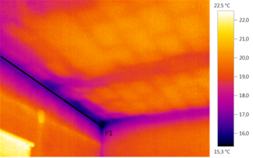
Thermal camera recording, triple junction
When making the energy calculations the results from the measurements were taken into consideration. With the help of the energy calculations and with the economical, environmental standards in mind we were searching for an optimal reconstruction. We haven’t managed to determine the best form for it because for that the owner’s personal needs must be taken into consideration. From the results of the energy calculations of the nearly 60 ways of doing the reconstruction we can say that in general the reconstruction in most cases should be carried out from an economical, environmental and comfort point of view.

