TÍMEA HORVÁTH
Agricultural Engineer
BSc, 3. semester
University of Szeged
Faculty of Agriculture
Supervisor:
Dr. Ferenc Lantos
Assistant professor, SZTE MGK

The effect of Spirulina and Chlorella green algae species on soil status conservation in sweet pepper growing

In Hungary the most important vegetables is the sweet pepper (Capsicum annuum L.). In today’s agriculture the preservation of soil fertility is a very important factor. In plant cultivation we can use organic nutrients or fertilizers to supplement soil nutrients. In the summer period of 2012 in sweet pepper (Capsicum annuum L.) growing experiment we used a complex Biofluid vermicompost and an organic nutrient composed of Spirulina and Chlorella green algae species. As control, we applied Poly-feed N:16; P₂O₅:9; ﻿K_{﻿2}﻿O:26 chemical fertilizer containing micronutrients for sweet peppers. At the end of the growing period we analysed the soil samples for humus status and other nitrogen-containing compounds of soil.
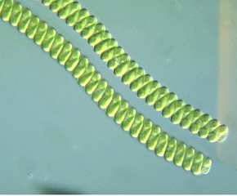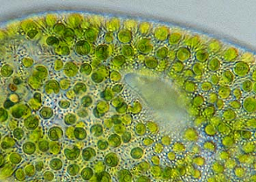
Figure 1. The cell structure of Spirulina (left) and Chlorella (right) green algae species
The experimental results of 2012 year have clearly demonstrated that the green algae treatment in the intensive sweet pepper growing for preservation of soil status, the addition of Biofluid use is advisable. However, several years of production experience is required to analyze the effectiveness. Ours major experience: “The natural soil conditions can only be restored by eco-friendly materials, which increase the productivity of the soil, but do not threat the environment. They restore the original ecosystem, which has been steadily destroyed by industrial production (J. Neyer)”.

