BENCE RADICS
medicine
Unified, 8. semester
University of Szeged
Faculty of Medicine
Supervisor:
Prof. Zoltán Hantos Ph.D.
professor, SZTE ÁOK

Within-breath changes in respiratory mechanics in healthy newborns

Introduction: Neonatal lung function data are usually measured with invasive methods, and hence originate from preterm infants requiring ventilator support. Little is known about the respiratory mechanics of healthy term newborns and no data are available on the within-breath variations. We aimed to measure the mechanical impedance of the respiratory system (Zrs), namely the cyclic changes of resistance (R) and the reactance (X) as the function of respiratory volume (V) and flow (V’) with a novel non-invasive method.
Methods: Zrs was measured by the forced oscillation technique superimposing a 16 Hz excitation signal during quiet sleep. Term newborns, within the first 24 hours after birth were involved in the study. The values of R and X within one breathing cycle at minimum (V_{min}) and maximum volumes (V_{max}) as well as inspiratory (V’_{in}) and expiratory flow peaks (V’_{ex}) were compared. In addition to steady-state breathing intervals the epochs of deep inspirations (sighs) were also examined.
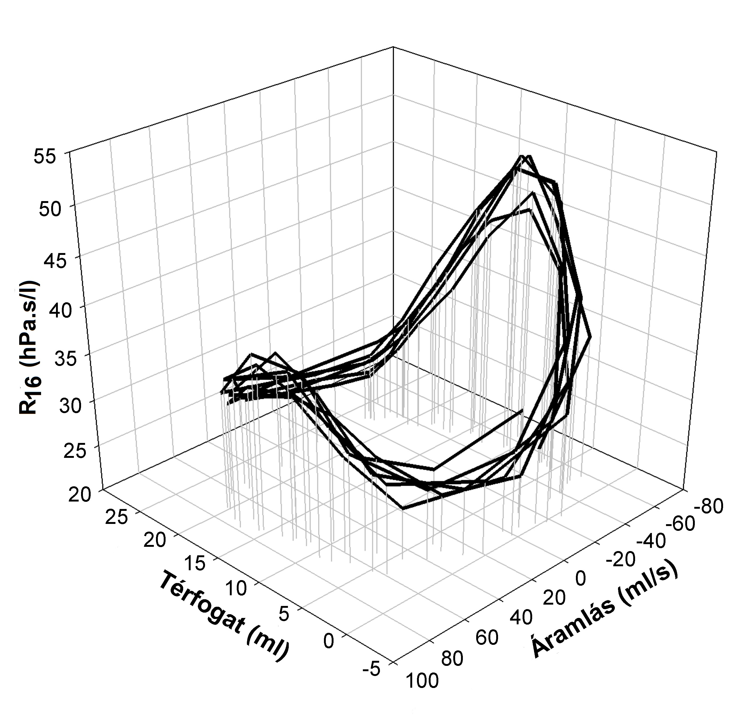
Results: Statistical analysis was performed on the data of 73 newborns (per vias naturales: 38, sectio caesarea: 35; m= 3331±430 g). The values of resistance at V’in and at V’ex were much higher (R_{V'in}: 46.2±22.2 and R_{V'ex}: 55.2±21.4 hPa.s/l, respectively) than that measured at zero flow in the same cycle, the latter being not statistically different from each other(R_{Vmin}: 30.7±10.4 vs R_{Vmax}: 30.2±9.9 hPa.s/l) (p< 0.001). The flow dependence was thus characteristic for R, while volume dependence was negligible. In turn, volume dependence was significant (p<0.001) for reactance (X_{Vmin}: -3.9±5.0 vs X_{Vmax}: -7.0±3.7 hPa.s/l). This volume dependence was also detected during deep inspirations. The way of delivery had no effect on the mechanical parameters.
Discussion: The flow dependence of R is probably due to the turbulence occurring in the narrow nasal pathway and in the glottic aperture. The volume dependence of X is caused by the increased tissue stiffness which is already detectable at tidal excursions.

