ÁDÁM BEDROSSIAN
Designer
MSc, 7. semester
Budapest University of Technology and Economics
Faculty of Architecture
Supervisors:
József Kolossa Dr.
assistant professor, BME ÉPK
Sándor Makrai DLA
assistant professor, BME ÉPK

Autonomous Home

My works is about a miniature living space which serves every major needs of the habitants. While designing the building I chose a place in an unique situation. It hangs from the bottom of the bridge over the Gellért waterfall. It has an elliptic shape and the supporting structure under it has the arch of the bridges bottom in the opposit direction this was optically it looks like an Eye what watches along the axis of Erzsébet bridge and Rákóczi street and has a nice panorama of Pest.
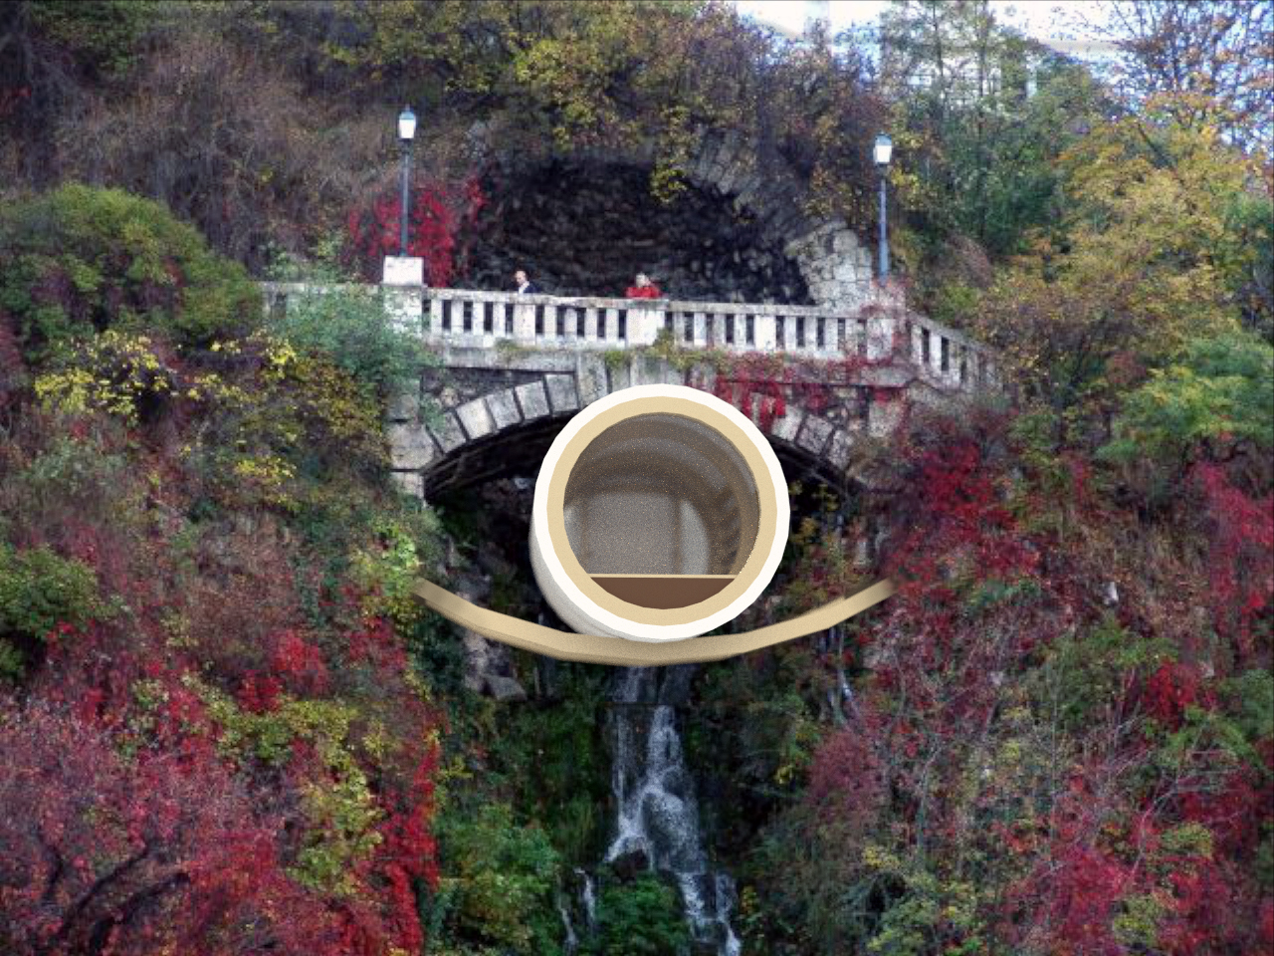
The enterieur space is fully functional how ever its really small thanks to the objects what are poping out of the floor when needed.
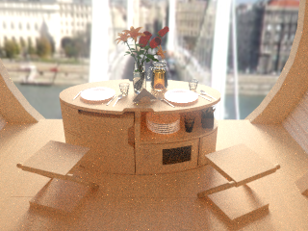
The philosophy of the building contains that also that becouse its a light weight small unit, so it can be moved to somewhere else. How ever this building has been designed to this particular place but it acts as a living creature what borns to somewhere and probably lives most of its live somewhere but its not mandatory for it to stay there for all of its life,
