DIÁNA BALOGH  Architect  Unified, 6. semester  Budapest University of Technology and Economics  Faculty of Architecture | ORSOLYA GNETH  Architect  Unified, 6. semester  Budapest University of Technology and Economics  Faculty of Architecture
Supervisor:
Katalin Marótzy
egyetemi adjunktus, BME ÉPK

Arrival to apartment houses of Ybl in Pest

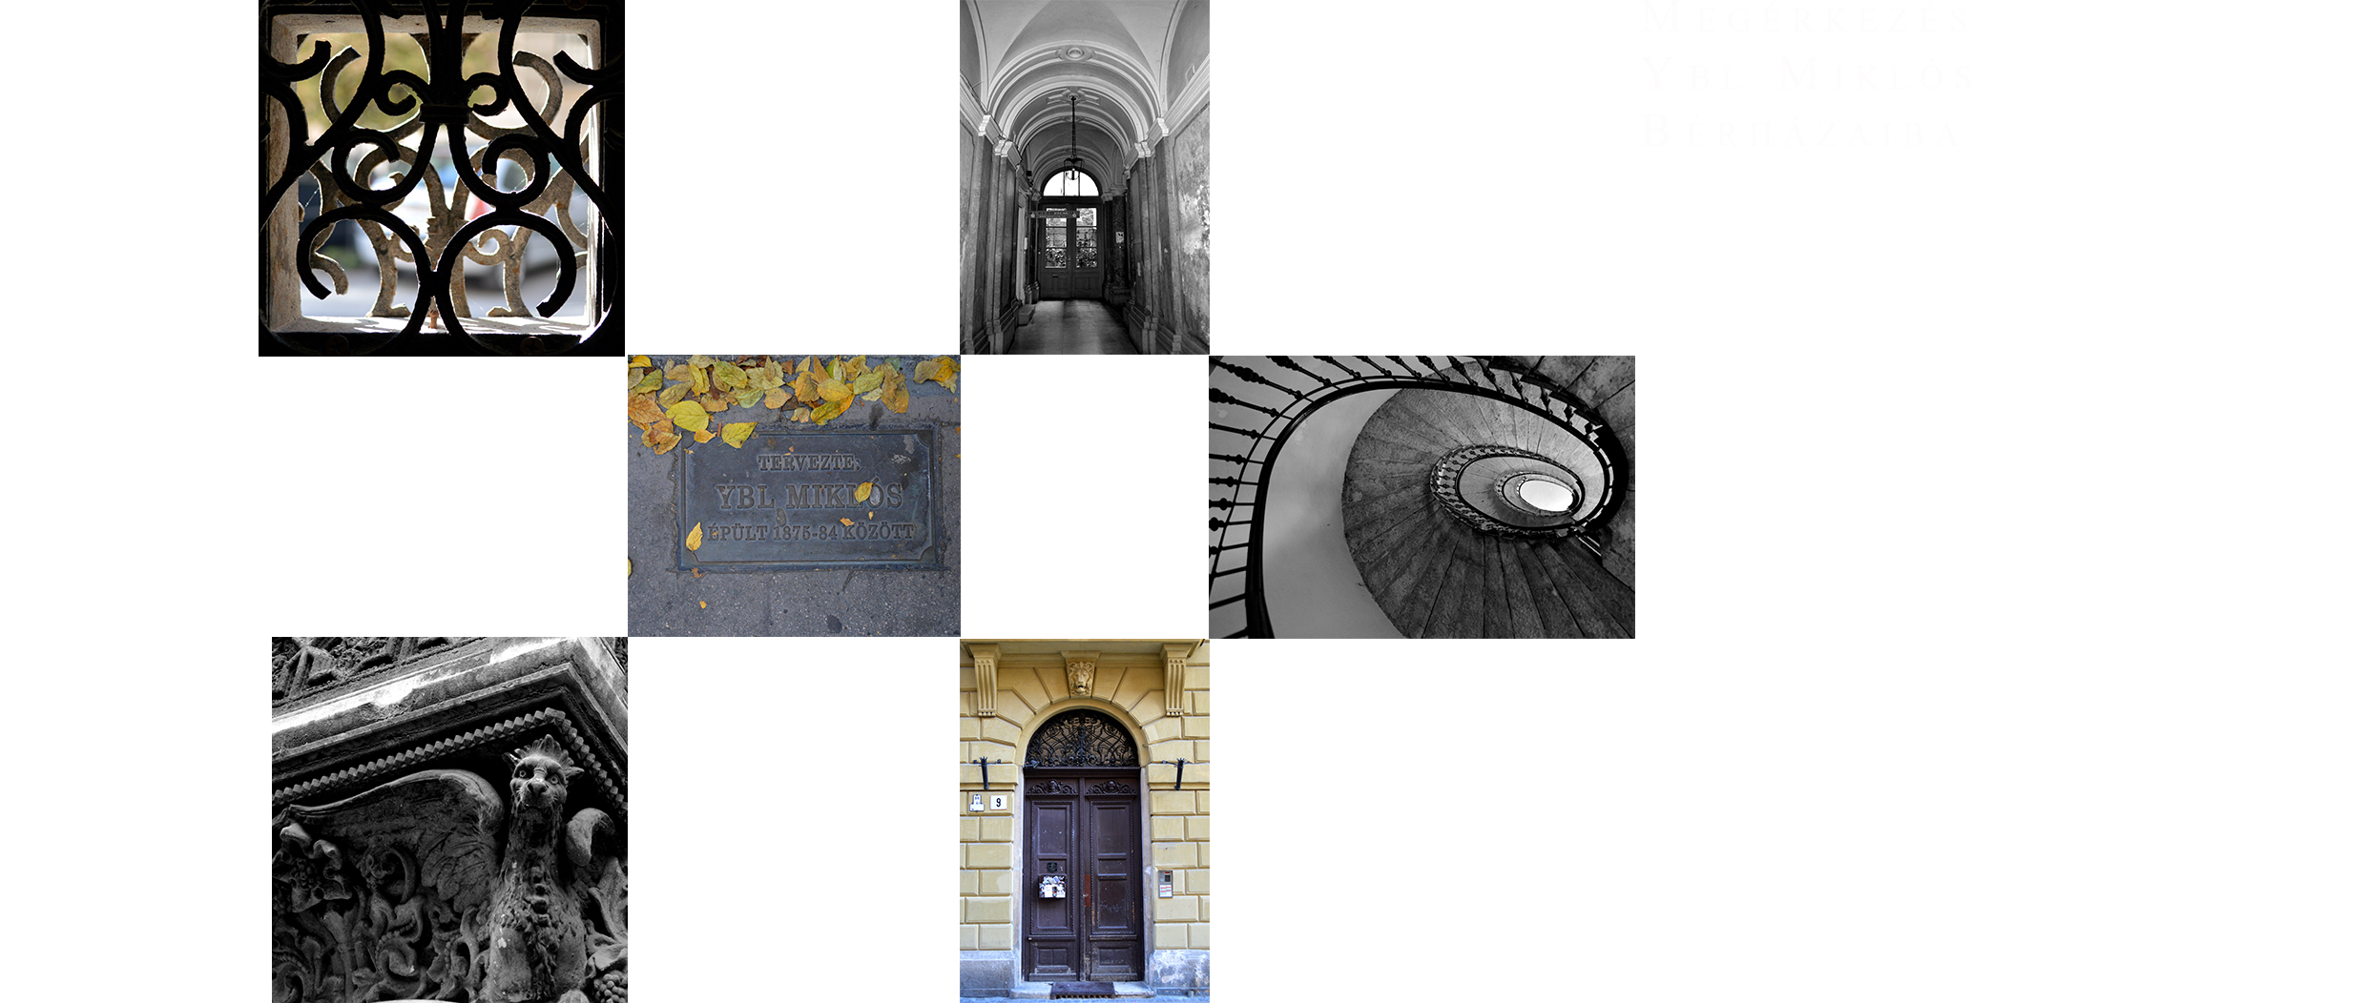

Arrival to apartment houses of Ybl in Pest
In 2014 we will celebrate 200th birth anniversary of one of the gratest figures of Hungarian architecture, Ybl .On this occasion, our choise has fallen on a lesser-known topic, theentrance places analysis of apartment houses and mansions in Budapest. The gates,doorways ,hallways and stairwells of the buildings tell the most about the metropolitan lifestyle of XIX th century and the funcional development of buldings.The solutions of architectural design can be extremly instructive as well.

