MÁRIA VISKY
Art History
BA, 6. semester
Babeș-Bolyai University, Cluj Napoca
Faculty of History and Philosophy
Supervisors:
Zsolt Kovács PhD
assistant professor, BBTE
Sebestyén György Székely
director, art historian, Quadro Gallery, Cluj Napoca

The nude and nakedness in the graphics of Egon Marc Lövith

In the second half of the 20th century, figurative art in Transylvania entered once again a period of prosperity, adopting old traditions and innovation as well. The ancient archetype of the body’s aesthetics is utilized in an entirely new manner in the modern and postmodern, being manifested not only in the society’s thinking, but also in the art world. This is shown in an exquisitely expressive way in the oeuvre of Egon Marc Lövith (1923–2009), a Hungarian artist of Jewish origin from Cluj, Romania. The presence of nakedness and of the nude in the graphical works of Lövith is treated with a variety of approaches, as the naked body appears in his nudes as a subject of observation, but in his works of Job or Adam and Eve he considers it as a means of a sensitive expression. By the selection of almost one hundred artworks on which the metamorphosis of the human body can be observed, I sought the answer to the question of how, and with what kind of purpose does the artist use the plasticity and power of expression of the female (or male) body in his creations.
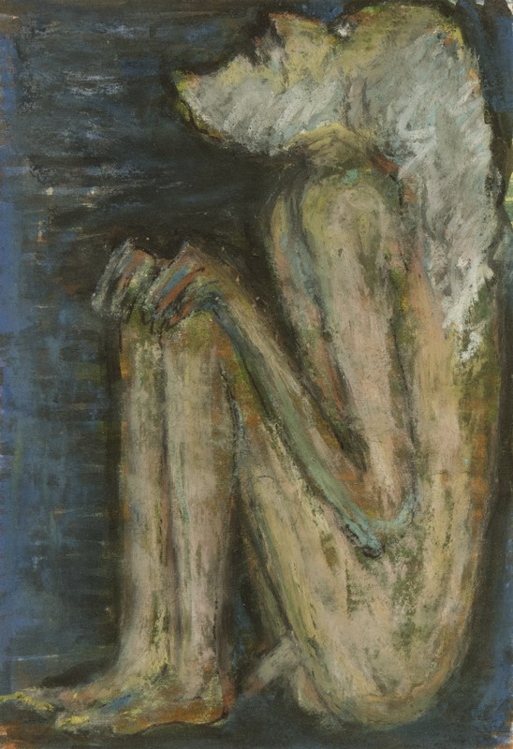
Egon Marc Lövith: Job [1990s]

