FANNI OROSZ
Visual imaging
BA, 3. semester
University of Szeged
Juhász Gyula Teacher Training Faculty
Supervisor:
Gábor Roskó
associate professor, SZTE JGYPK

dissolve

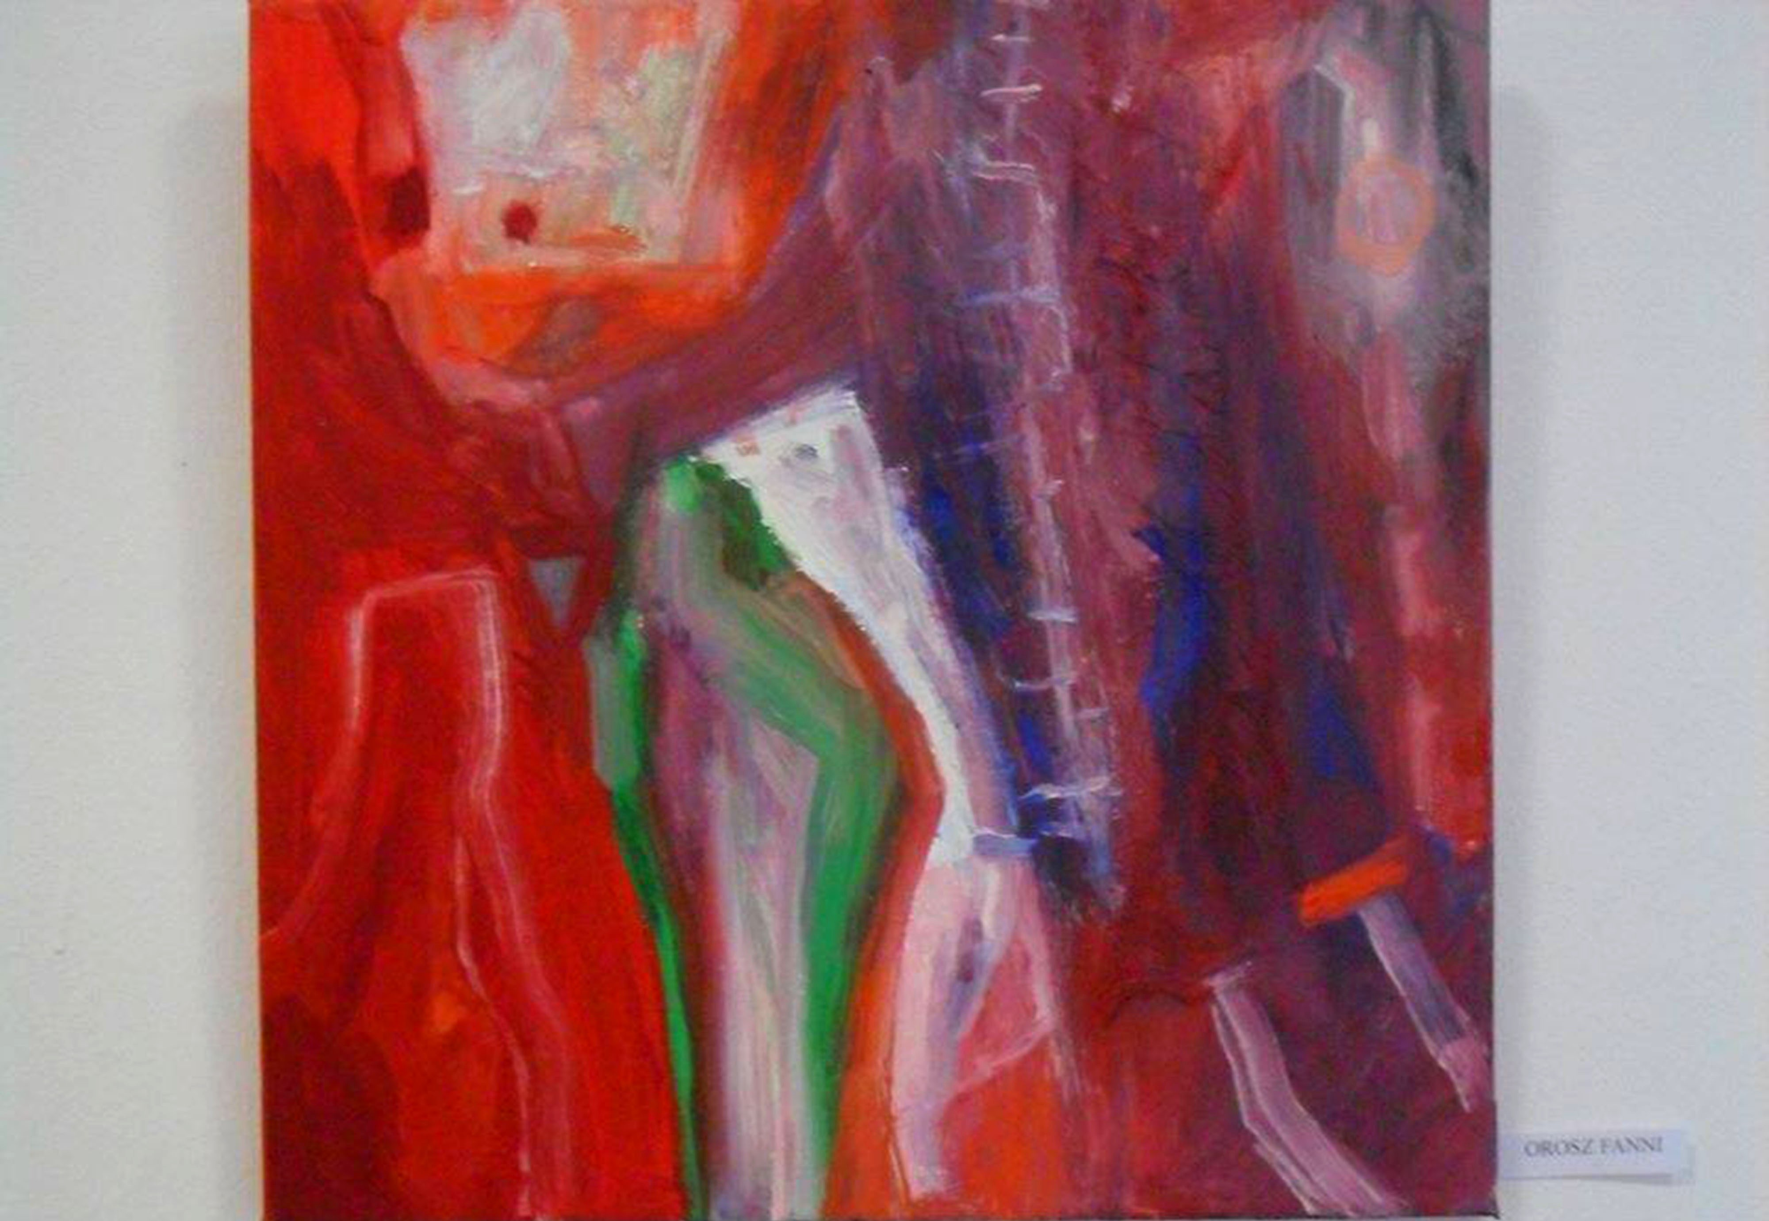
This painting was made for the 2013’s TDK which was painted on canvas with acrilyc paint in 40 x 40 cm size. The title of my work is transformation. Usually I don’t like to give titles for my works in order not to control the reciever, because these are inside impressions and I think it’s better to give more freedom outside of the picture also. Besides acrilyc paint I used some other material to make different textures. The main view-point is related to the connection between the subconsious movements and between the more conscious activities. I would like to create an atmosphere around the picture’s area what spreads from the picture which is the print of my feelings. For me it’s like to create a sacral surroundings to make a memorial for my feelings what are always transforming. The using of complementer colours is refers to the intensive feelings, to make a contrast, and to add some tense to the picture. This combined with some blue-purple colours to make a transition and also to make it more harmonic, and more balanced. I am interested in the line’s and the bigger gesture’s connections and how they reflect to each other on the surface. To my mind using graphical elements, such as lines it fills the content with concrete. I am thinking in a nonfigurative way to emphasise on the atmosphere. I used symbol elements to play with the composition and to also add a meaning for the motives. To finding myself more deeply is the inspiring power in my art. The inside is more important to me than the outside, despite the inside movements appears outside of the picture.

