ZOLTÁN DÉVAI  Architecture  Unified, 13. semester  Budapest University of Technology and Economics  Faculty of Architecture | NORBERT JUHÁSZ  Architecture  Unified, 12. semester  Budapest University of Technology and Economics  Faculty of Architecture
Supervisor:
Gábor Üveges Dla
associate professor, BME ÉPK

Photography on Architecture

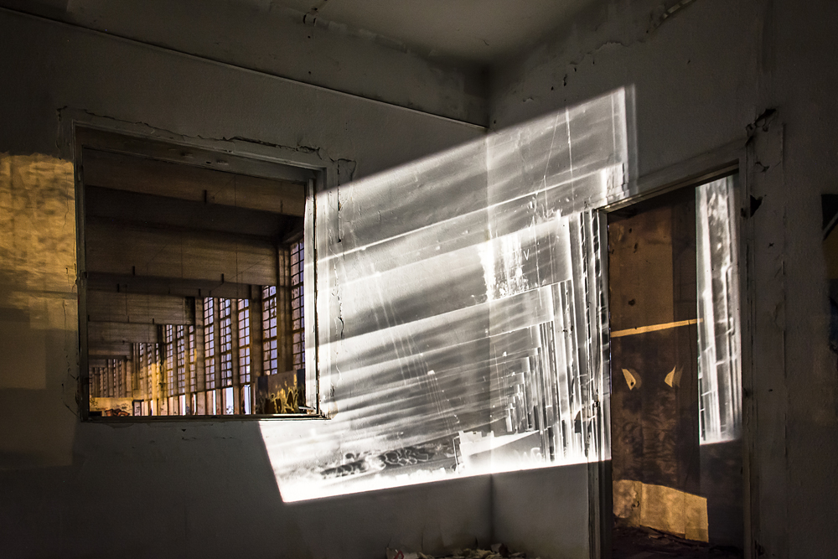
The two complex, similar but still different creative fields meet. They stop and start a friendly conversation. One talks about the other, the other talks about this one. They speak: not about the origin or future of their existence but about their every days. Not everything, but their common grounds, in a common language. They don't want to convince or change each other, neither to look like the other - they just simply chat. The architecture is on the photography and the photography is on the architecture.
In this conversation the communication channel is us, the creators. We don't want to create an ultimate truth, this is only one - our - interpretation. This is only one chapter in the book of the two art's friendship.
In our TDK, we would like to make up the genre of architecture and photography as equal participants. Not to create architectural photography (where the photo is subordinated to the building) or a setting made for the photo (where the architecture is subordinated to the photo), but establish an act, an idea where both genres has an effect on each other.
Is this possible? The photographer mostly creates a planar element from a spatial situation, where the space is usually still important. The architect creates space from planes, with planar drawings. Space is essential to both: one abstracts it to a plane, the other uses planes to create one. They dance so close to each other that we think it is possible. If architecture opens up and becomes the medium of the photography, it can pull the geometrically planar photo into the space. Meanwhile the photography can be about the architecture, and then again it can make the spatially changed photo into another photo from a different point of view. If this happens, then both parties have spoken: they had a conversation.

