ESZTER KISS
Craftmanship
BA, 1. semester
Budapest College of Communication and Business
Faculty of Arts and Communication
Supervisor:
Erika Rejka
College Docent, BKF KMK

Konokono

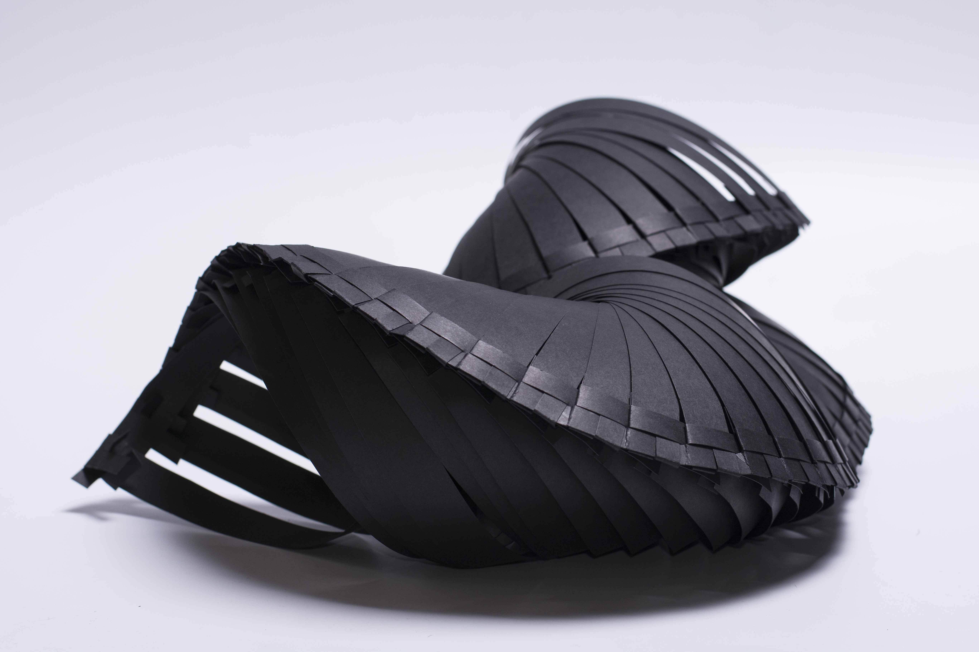

My tender assignement was a family of casual jewels, based on a paper statuette. The starting point was form study. My element choosen was an ungula which had to classify into the space, to create a new form without glueing or stitching, fitting only to own material. This gave the idea to create jewels from this material. First, from an A4 sheet of paper I prepared the model of the base element, and tried to clamp it in different ways. I cut from the paper 2 cm widebands and made a snick on both ends. Then I tied the opposite parts and folded the ends to hold together this round form. So I prepared the first fitting point. Knowing that I will use this base element further, I experimented with other kinds of papers, too. The photo cardboard proved to be the most suitable, because it is hard enough, but still fabricable. First I used the same size as in the first experiment, I fitted together, but I made a cut also on the side of the base element, so I could hook the part turned back from the fitting pont, which gave a better keeping. First I made a structure like the a bayonet-joint. Due to this solution it became stable enough, so I could get a long series of the elements, but I faced the problem, that it was holding only in one direction. When I pulled in the opposite direction, it was slipping. The solution was to make T-form cut. So I got two fitting points and the form does not go to pieces in no directions. By means of these it is easily constructable and I can change the form using different ratios. The longer series I built, the more it became helical. Due to the fitting, the jewel became movable, flexible and multifunctional. If I turn it in one direction, or move it, it goes back to the original direction. This makes it wearable on such points of the body, as e.g the elbow, where a rigid form couldn’t give such a big margin. In the future I’d like to experiment with other paper-like but more permanent materials, like plastics. This could give the advantage of the transparency and harder material, and also the possibility to make a colourful composition. It is also possible to develop the joints, what I started to do. Later I would like to modulate the form, too, in different way, and change directions and the twists, and construct at least 3 different jewel objects.

