LEVENTE SZÁSZ
Environmental Design
BA, 5. semester
Budapest College of Communication and Business
Faculty of Arts and Communication
Supervisor:
Mihály Hefkó
College reader, BKF KMK

Modular furniture system with bent metal

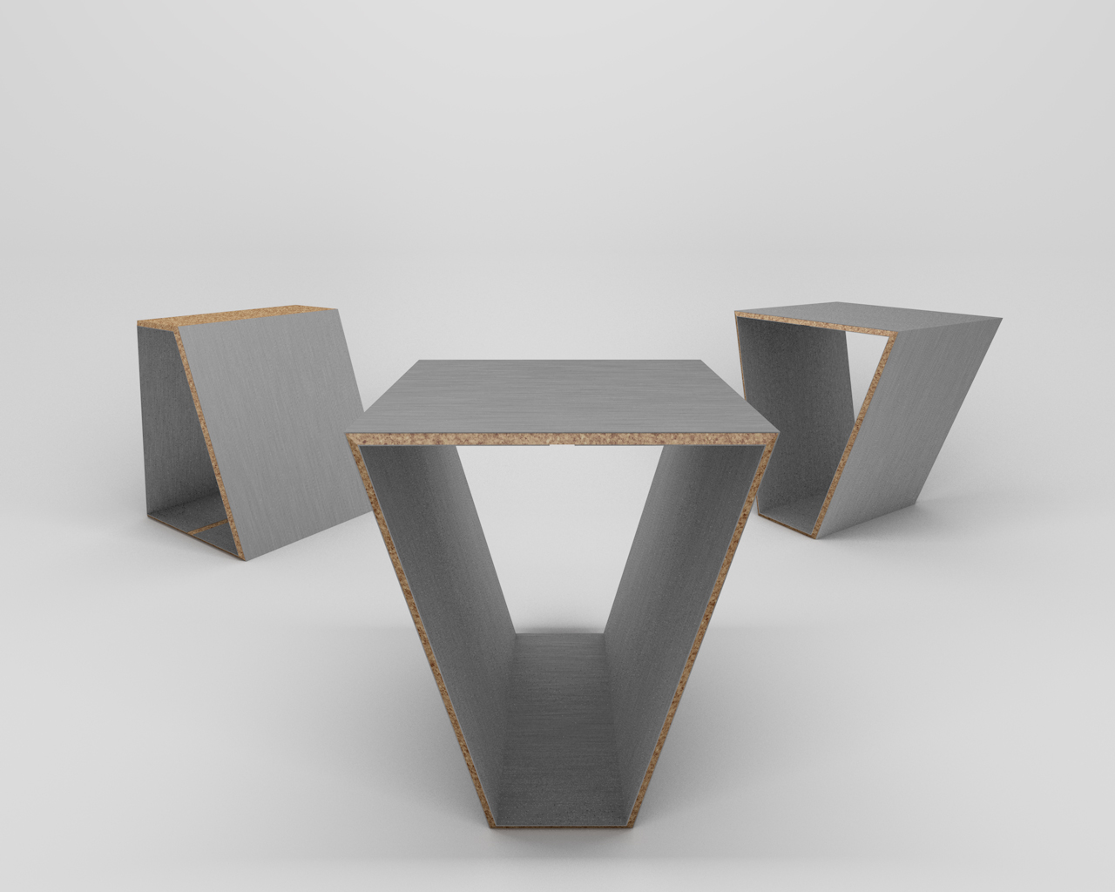

The S L A B is a piece of furniture which is functional on its own, but could also form a specific system by using more of the elements. This way the user can create different functions. The structure has a special, bound precept. The sides of each element serve as connections where a special lock was placed. The system’s modularity is infinite, thus basically it is up to the user what kind of compositions can be born. Another important part of the design was the experiment of material combination, which I refer to as ’sandwich’ overlay. Finally, two materials were chosen; stainless steel and corkwood or gum. The external shell of the element is 1mm steel on both sides, which straddle the 8mm corkwood inside. These make 1 cm-s for each element. The steel makes the element strong while the corkwood makes it flexible. Thereby, the ’sandwich’ system makes the whole element stiff but still resilient. Industrial glue is used to fix together the materials. The height of one element is 40cm-s and the width is 33cm-s. The weight of it is approximately 7-8 kg-s, hence it is not too heavy. The surface of the stainless steel is already coated, therefore the furniture can be placed outdoors and indoors as well. It was important to make the execution process with the bending machine as accurate as possible, so the geometry is open. The top arcs are 75-75 degrees, and the lower ones are 105-105. The third keystone of the design were the aesthetics. When designing the S L A B, I aimed for establishing an elegant piece of furniture, which could be achieved thanks to the material combination and the shape. It is created to be a determinative part of the given space and a new experiment for every user.

