SÁNDOR BALÁZS KIRÁLY
Chemist
MSc, 3. semester
University of Debrecen
Faculty of Science and Technology
Supervisor:
Dr. Tibor Kurtán
associate professor, DE TTK

Knoevenagel-hetero Diels-Alder reactions for the preparation of condensed heterocycles

Keywords: domino reaction; hetero Diels-Alder; O,N-heterocycles
The Goal of my scientific student research work was to prepare condensed O,N-heterocycles containing chroman and tetrahydroquinoline moieties with domino reactions.
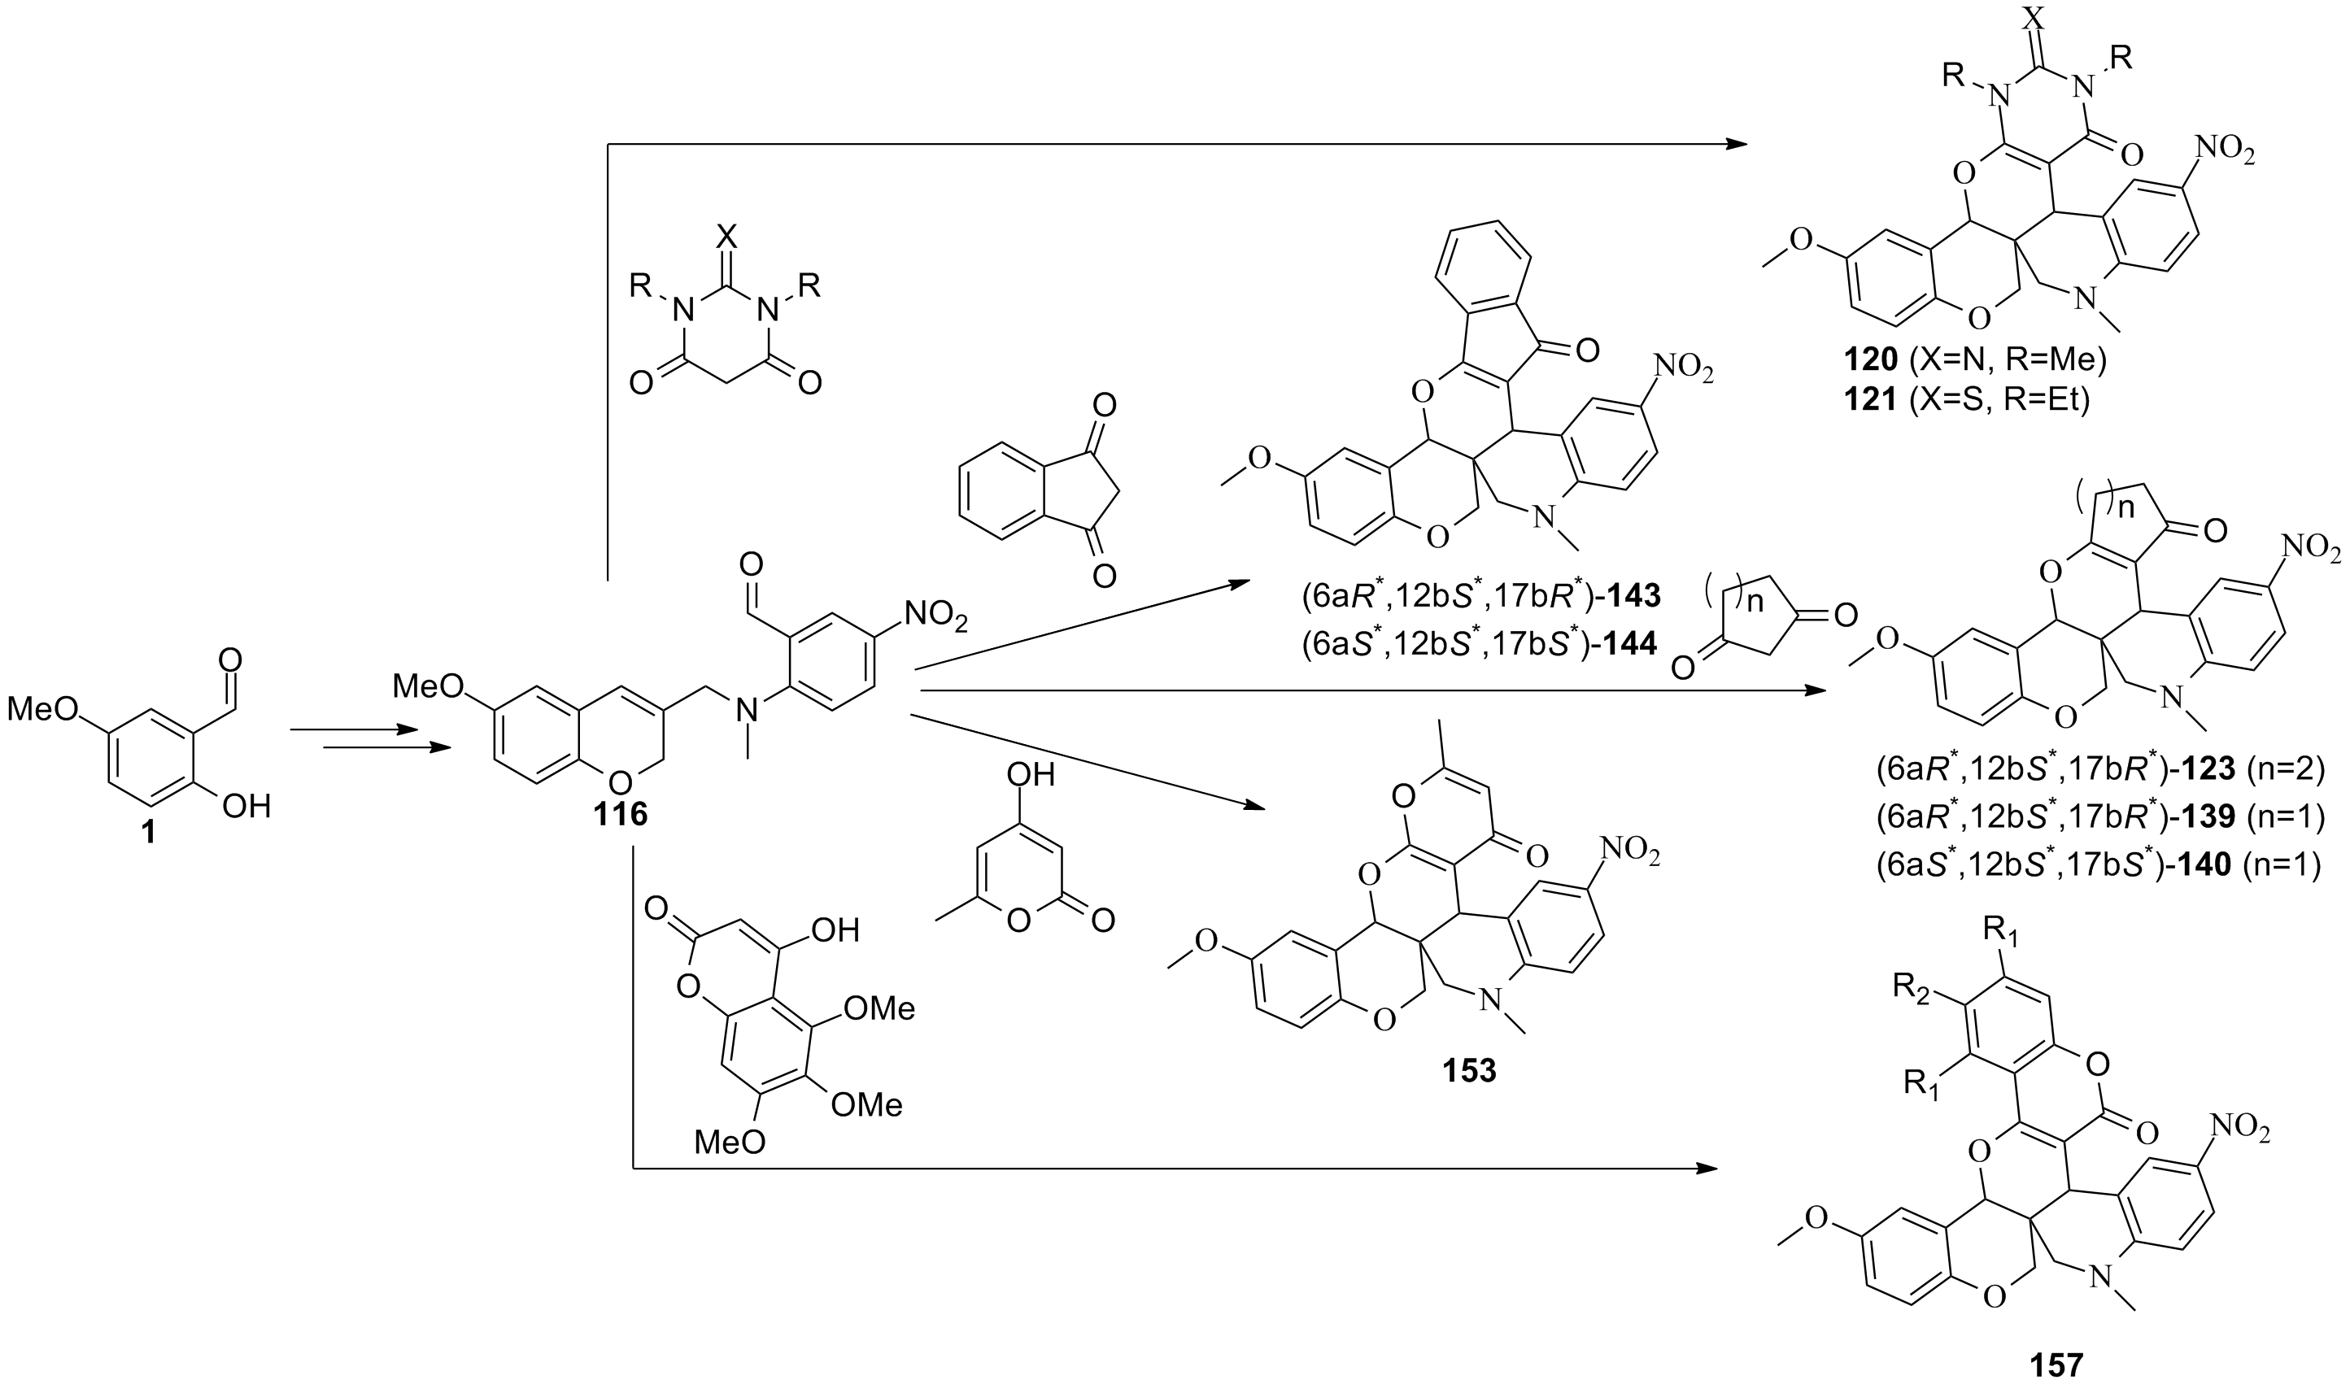
In the research work, the following results have been accomplished:
- Starting from 5-methoxysalicylaldehyde, an achiral (2H)-chromene derivative was synthesised in 3 steps with 50% overall yield, which could serve as a starting material for the subsequent Knoevenagel-hetero Diels-Alder domino reactions with 1,3-dicarbonyl derivatives.
- By reacting compound 116 with cyclic 1,3-dicarbonyl derivatives, 11 condensed O,N-heterocycles, containing new ring systems were prepared in Knoevenagel-hetero Diels-Alder domino reactions.
- The diastereoselectivity of the hetero Diels-Alder reaction was studied by NMR measurement (NOESY and full NMR assignment by 2D-NMR methods), chiral HPLC, HPLC-ECD studies and TDDFT-ECD calculations, which allowed the assignment of relative configuration for the diastereomers as well as of the absolute configuration for the separated enantiomers.
- In the cicloaddition step 3 new chirality centers are established diastereoselectively. 7 covalent amine-type and 4 non-covalent TADDOL-type chiral nonracemic organocatalysts were tested in enantioselective organocatalytic reactions. Significant enantioselectivity could not be achieved int he applied reaction conditions but L-proline changed the diastereoselectivity considerably.
- The antiproliferative activity of the final products was tested on colorectalis adenocarcinoma human cell lines, and the 123 derivative showed 10 μM IC₅₀ value int he preliminary studies.

