Sensing hydrogen peroxide by carbon nanotube/horse radish peroxidase bio-nanocomposite
Melinda Magyar*^{,1}, Kata Hajdu¹, Tibor Szabo¹, Balazs Endrodi², Klara Hernadi³, Endre Horvath⁴, Arnaud Magrez⁴, Laszlo Forro⁴, Csaba Visy² and Laszlo Nagy¹
¹ Departments of Medical Physics and Informatics, University of Szeged, Rerrich Bela square 1., H-6720 Szeged, Hungary
² Department of Physical Chemistry and Materials Science, University of Szeged, H-6720 Szeged, Hungary
³ Department of Applied and Environmental Chemistry, University of Szeged, H-6720 Szeged, Hungary
⁴ Institute of Physics of Complex Matter, Ecole Polytechnique Federale de Lausanne, CH-1015 Lausanne, Switzerland
Received ZZZ, revised ZZZ, accepted ZZZ
Published online ZZZ (Dates will be provided by the publisher.)
Keywords Horseradish peroxidase, carbon nanotube, ITO

H₂O₂ is a product of reactions catalysed by several oxidase enzymes and it is essential in environmental and pharmaceutical analyses. The most commonly used enzyme in understanding the biological behaviour of catalysed oxidation of H₂O₂ is horseradish peroxidase (HRP). In our experiments HRP was bound to carboxyl-functionalized multiwalled carbon nanotubes (MWNT-COOH) by N-Hydroxysuccinimide (NHS) and 1-[3-dimethylaminopropyl]-3-ethyl-carbodiimide (EDC) crosslinkers. The activity of this bio-nanocomposite and the limit of detection (LOD) for H₂O₂ were determined by measuring the fluorescence of tetraguaiacol (which chemical is the product of guaiacol oxidation after addition of H₂O₂ to the reaction mixture) as a function of time. The hydrogen peroxide biosensor we developed exhibited a detection limit of 1.2 µM H₂O₂/sec which resolution was better than the one measured in solution by about a factor of two (it was 10 µM H₂O₂/sec in solution). An attempt has been made to measure the concentration of H₂O₂ in an electrochemical cell with HRP immobilized on the surface of an electrode made of ITO (indium tin oxide, a transparent conductive oxide) and MWNT.

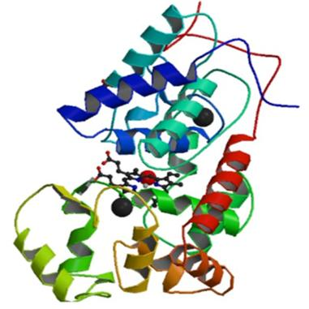
Copyright line will be provided by the publisher

1 Introduction Carbon nanotubes (CNTs) have unique properties, as good conductivity, high chemical stability and it is possible to bring them close to redox centers of proteins [1]. Peroxidases are heme containing enzymes which can oxidize hydrogen atoms and for example xenobiotics in the presence of H₂O₂ [2]. Hydrogen peroxide is a strong oxidant so it is important to determine its exact concentration in environmental and pharmaceutical analyses.
Horseradish peroxidase (HRP, Figure 1) is one of the representatives of peroxidases, which has long been studied in understanding the biological behaviour of catalyzed oxidation of the substrates H₂O₂. It is the most commonly used enzyme in H₂O₂ detection when electrochemical biosensors are aimed to prepare.

Figure 1 Three dimensional structure of the horseradish peroxidase. The heme group is located in the center (black) with the iron atom (red).

The direct electron transfer between HRP and the electrode is relatively slow and hardly detectable, however, in the presence of a suitable mediator (e.g. carbon nanotubes) it can be facilitated while its bioactivity remains [3].
In order to determine the enzyme activity of HRP we used the chemical decomposition of H₂O₂ by the enzyme. To follow this process we chose guaiacol, which reagent can be simply oxidized and its oxidation results in coloured product (tetraguaiacol). The accumulation of this product can then be easily detected by the specific light absorption or emission (fluorescence).

4 H₂O₂ + 1 guaiacol → ^{enzyme} → 4 H₂O + tetraguaiacol

Although carbon nanotubes possess many unique properties the major problem in using them in biological systems is their poor dispersability in all types of solvents because of the large intertube van der Waals interactions [4]. In order to avoid this inconvenience HRP was immobilized on the surface of an electrode made of indium tin oxide (ITO), a transparent conductive oxide and multiwalled carbon nanotubes (MWNTs).
2 Experimental
2.1 Sample preparation Carboxyl-functionalized multiwalled carbon nanotube (MWNT) was activated by the addition of crosslinkers NHS (N-hydroxysuccinimide) and EDC (1-[3-dimethylaminopropyl]-3-ethyl-carbodiimide). After the activation procedure the mixture was dialyzed to remove the unbound crosslinkers. Than the HRP enzyme solution (1 µM) was added to the activated MWNT and it was mixed at 4°C for 3 hours. Finally the sample was separated and washed by ultracentrifuge until the supernatant did not show enzyme activity [4].
2.2 Absorption kinetics Absorption change was measured at 470 nm by a single-beam kinetic spectrophotometer of local design [5]. The enzyme activity can be determined by the known absorption coefficient (see in Par. 2.4).
2.3 Fluorescence measurements Fluorescence was measured by a fluorimeter (Perkin Elmer MPF44A). The excitation and the emission wavelengths were 300 nm and 350 nm, respectively. The reaction was initiated by addition of H₂O₂ under stirring, and the formation of the tetraguaiacol was followed by the appearance of its fluorescence. Then, the amount of H₂O₂ was calculated from the reaction stoichiometry.
2.4 Enzyme activity The rate of the formation of the guaiacol (proportional with the H₂O₂ consumption) can be determined by the change of the fluorescence intensity after calibration of the instrumental parameters to the known extinction coefficient (ε(λ)guaiacol = 26611 M⁻¹cm⁻¹). Applying the Beer-Lambert law the amount of the oxidized H₂O₂ can be calculated.
The absorption change:
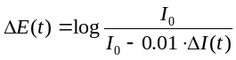
The change in the fluorescence:
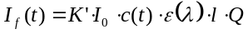

Here I₀ is the incident light intensity, ΔI(t) the change of light intensity in time, I_{f}(t) the fluorescence intensity in time, c(t) the concentration change in time, ε(λ) the extinction coefficient, l the optical path, Q the quantum yield of fluorescence and K’ is the instrumental constant.
2.5 Preparation MWNT-COOH/enzyme covered ITO electrode ITO covered glass (CEC020B, Praezisions Glas & Optik GmbH, Iserlohn, Germany)) was cleaned by oxygen plasma cleaner. After silanization the carboxyl functionalized MWNTs (0.14 mg/ml) activated by the addition of crosslinkers NHS and EDC was deposited on the top of the ITO then washed. Horseradish peroxidase was crosslinked to the ITO/MWNT electrode.
2.6 Cyclic voltammetry The electrochemical activity of the „enzyme electrode” was checked by cyclic voltammetry as well.
Cyclic voltammograms were measured using a PGSTAT10 potentiostat/galvanostat at ambient temperature in dark. A three-electrode cell containing 50 ml potassium phosphate buffer (0.1 M, pH 7.0), 20 mM KCl was used. The working electrode was the enzyme electrode fabricated from ITO, carboxyl functionalized carbon nanotubes and peroxidase enzyme. The counter and reference electrodes were platinum and Ag/AgCl/3M NaCl, respectively. The scan rate was 50 mV s⁻¹ [6].

3 Results and discussions
3.1 Determination of the initial rate of H₂O₂ decomposition by measuring absorption change and fluorescence In order to calibrate the fluorescence change and the enzyme activity the initial rate of the H₂O₂ decomposition calculated from the absorption change (Fig. 2) was measured and plotted as a function of the enzyme concentration. The conversion of guaiacol to tetraguaiacol was followed by measuring the fluorescence at the peak of the guiacol emission maximum (355 nm, Fig. 3) and the initial rate of the fluorescence change was calibrated to H₂O₂ concentration (Fig. 4).
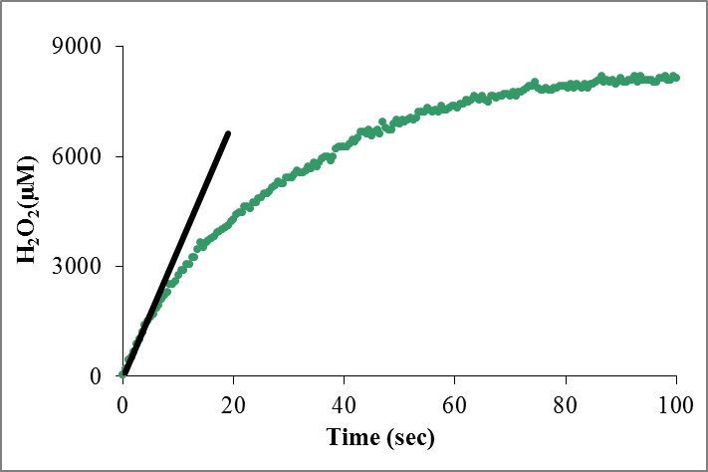

Figure 2 The amount of H₂O₂ oxidized by 16 nM HRP as a function of the time. Figure was made by the absorption change of tetraguaiacol. H₂O₂ was calculated by using the extinction coefficient given in the text.
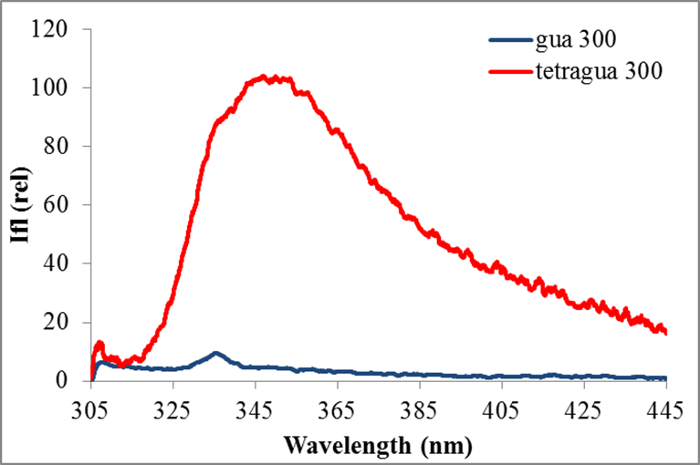

Figure 3 The fluorescence emission spectra of the guaiacol and tetraguaiacol at 300 nm excitation. Figure shows that guaiacol has very low fluorescence yield unlike the tetraguaiacol. The biggest change is at 355 nm emission.
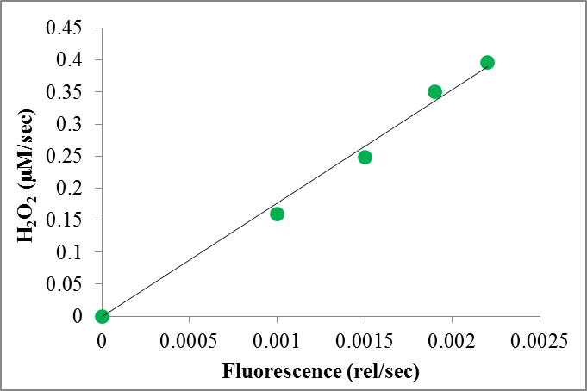

Figure 4 The amount of the oxidized H₂O₂ as a function of the initial slope of fluorescence change of tetraguaiacol (a joint calibration line made from the concentration-dependences based on the absorption and fluorescence kinetics).

3.2 Fluorescence measurements on the HRP/MWNT complex Figures 5 shows the fluorescence of the tetraguaiacol formed by the HRP/MWCNT complex when the enzymatic reaction became saturated. The fluorescence increase indicates clearly that the complex we prepared shows considerable enzyme activity. No fluorescence increase was measured with MWCNT without the enzyme indicating that illumination of the MWCNT alone does not contribute to the guaiacol oxidation.
Based on the initial slopes of the fluorescence changes at different sample quantities and the calibrations to the instrumental constant (Fig. 4) the amount of the oxidized H₂O₂ was calculated.
Under our experimental conditions our complex was able to oxidize H₂O₂ with the rate of 1.2 µM H₂O₂/sec, which resolution was better than the one measured in solution by about a factor of two (it was 10 µM H₂O₂/sec in solution).
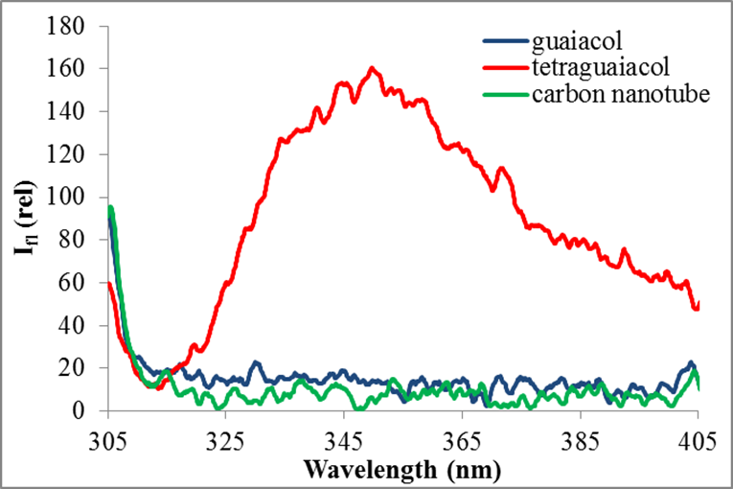

Figure 5 The emission spectra of the complex before the reaction (guaiacol), after the reaction (tetraguaiacol) and the carboxyl-functionalized carbon nanotube as reference. It proved that we managed to bind the peroxidase enzyme to the carbon nanotube.
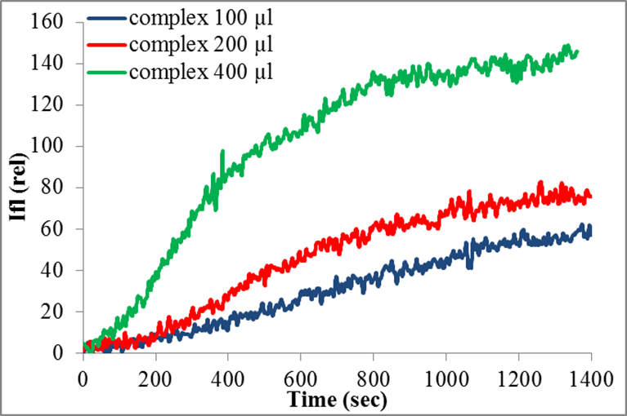

Figure 6 The fluorescence of tetraguaiacol as a function of time in different complex concentrations.

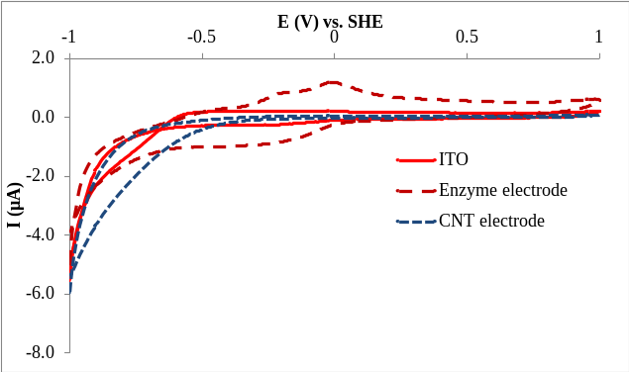

Figure 7 Cyclic voltammograms of ITO, MWCNT and enzyme electrodes (A, as references), and after addition of 5 mM H₂O₂ (B). CNT was immobilized on ITO and the enzyme electrode was fabricated with immobilized HRP on MWNT-COOH deposited on ITO.

3.3 Cyclic voltammetry Figure 7 shows the cyclic voltammograms of ITO, MWCNT and HRP/MWCNT/ITO enzyme electrodes before (A, as references), and after addition of H₂O₂ (B). Figure indicates that there is no catalytic redox transition at around -350 mV potential in the absence of H₂O₂. Also, the MWCNT electrode does not facilitate redox transition at this potential alone (Fig. 7, B). This later found is not in agreement with the results of Wang et al. (2008) [7], which authors reported H₂O₂ reducing activity by MWCNT electrode. However, these authors did not exclude the possibility of either edge plane like-sites/defects or metallic impurities in explaining this activity.
Both ITO and the HRP/MWCNT/ITO enzyme electrodes show direct electron transfer at -350 mV which is characteristic to H₂O₂ reduction indicating that our electrode is able to catalyse the splitting of this substrate.

4 Summary Our results indicate that we managed to bind HRP enzyme to carboxyl functionalized MWNTs. We worked out a fluorescence method to determine the amount of decomposable H₂O₂ by our bio-nanocomposite in a sensitive way. The limit of detection (LOD) of our complex was found to be 1.2 µM H₂O₂/sec which value can be further improved. A HRP/MWNT/ITO electrode was fabricated which was able to oxidize H₂O₂ as proved by electrochemical (cyclic voltammetry) measurements. Results show that electron transfer can be facilitated between active sites of the enzyme and the surface of the electrode substrate.

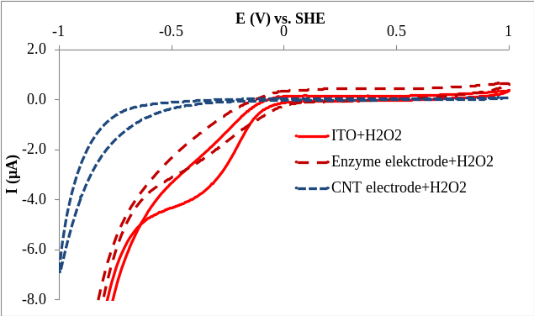

Acknowledgements This work was supported by grants from Switzerland through the Swiss National Science Foundation (IZ73Z0_128037/1) and Swiss Contribution (SH/7/2/20), by the Hungarian OTKA (K81180) and the COST TD1102.
References
[1] J.J. Gooding et al., J. Am. Chem. Soc. 125, 9006-9007 (2003).
[2] H. Wenying et al., Journal of Photochemistry and Photobiology A: Chemistry 182, 158-167 (2006).
[3] J.L. Huang, Y.-C. Tsai, Sensors and Actuators B 140, 267–272 (2009).
[4] N. Lebedev, S. A. Trammell, S. Tsoi, A. Spano, J.-H. Kim,J. Xu, M. E. Twigg, and J. M. Schnur, Langmuir 24, 8871–8876 (2008).
[5] L. Nagy, F. Milano, M. Dorogi, M. Trotta, G. Laczkó, K. Szebényi, Gy. Váró, A. Agostiano, and P. Maróti, Biochemistry 43, 12913–12923 (2004).
[6] L. Yoon-Mee et al., Biotechnology Letters 28, 39-43 (2006).
[7] Z. Wang et al., Electrochemistry Communications 10, 306–310 (2008).

* Corresponding author: e-mail magyarmelu@gmail.com, Phone: +62 544 121, Fax: +62 544 121

